**Title of contribution, Times New Roman, 14 bold**

Author Namea, Author Nameb, Author Name*a, etc, Times New Roman, 12

*a Institute of first author, address, city, country, Times New Roman, 11, italic*

*b Institute of other author, address, city, country, etc.*

* Corresponding author: [email@address.com](mailto:email@address.com)

The name of the presenting author should be underlined. The main text (in Times New Roman, 11 pts, 1.5 spacing) of the abstract must not exceed one page. It may contain equations as well as plots or other graphics. Equation should be typed using the equation tool and math symbols.

 (1)

Each figure or image should be accompanied by a caption.

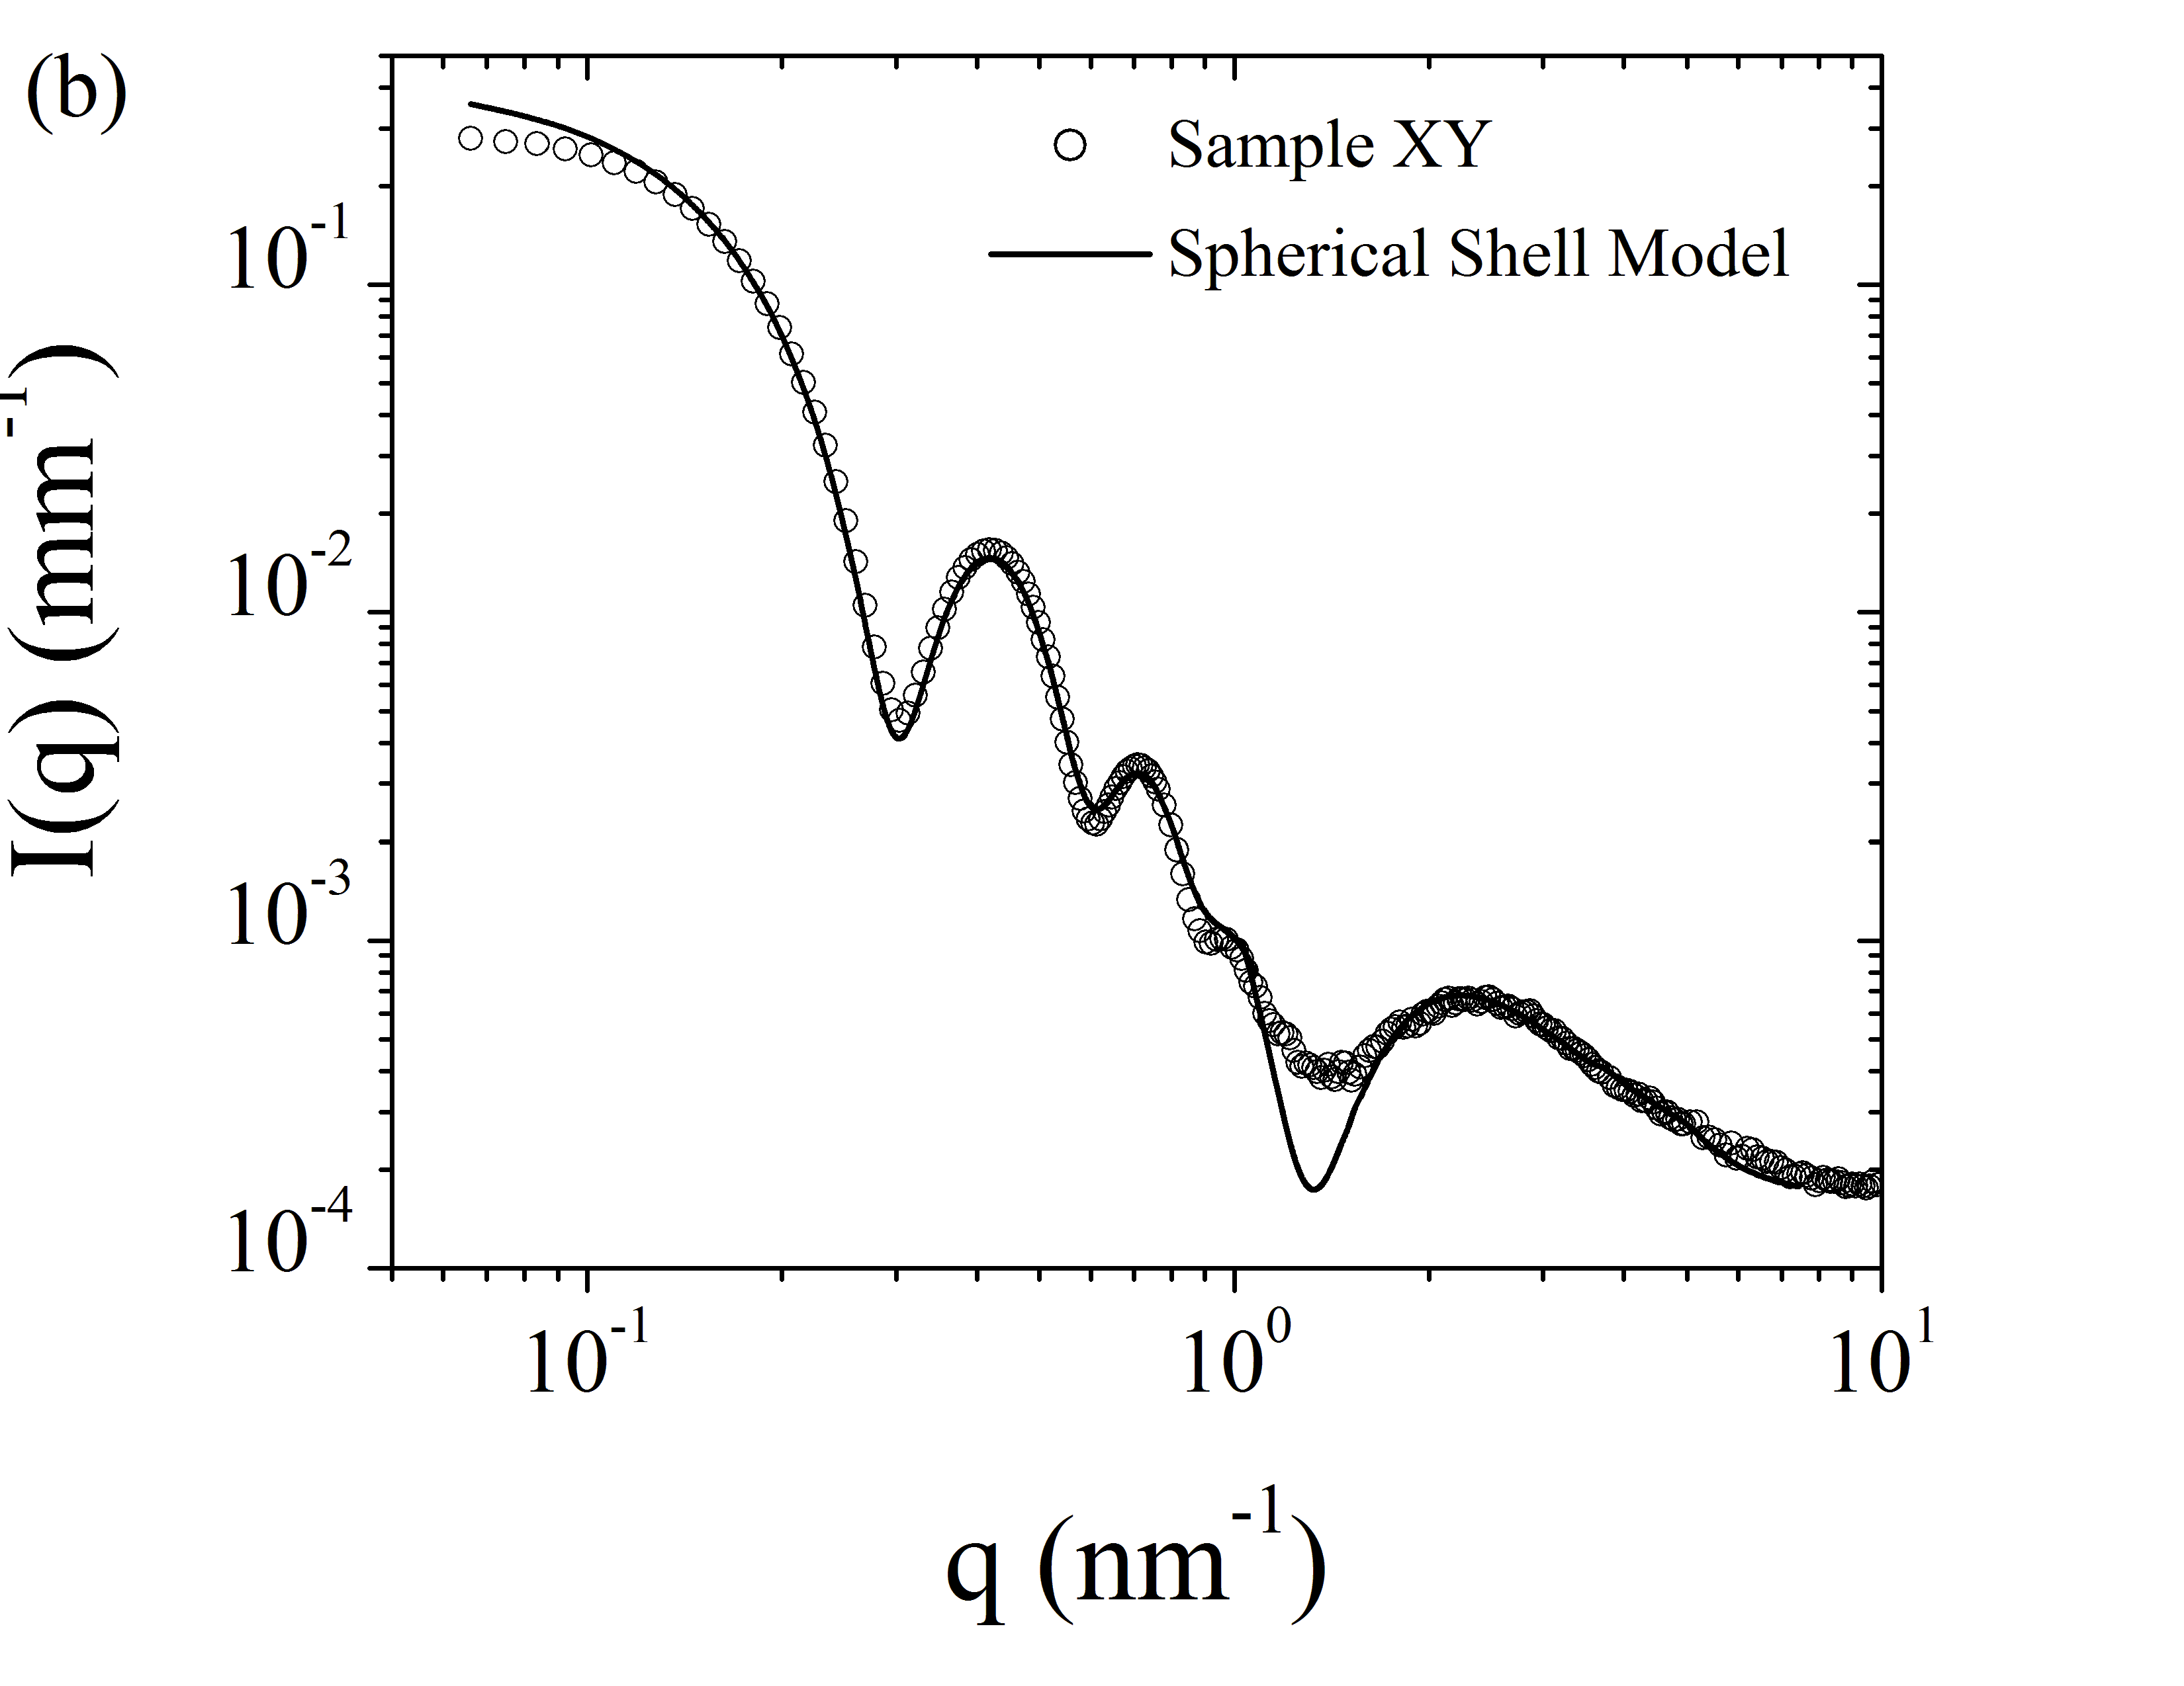

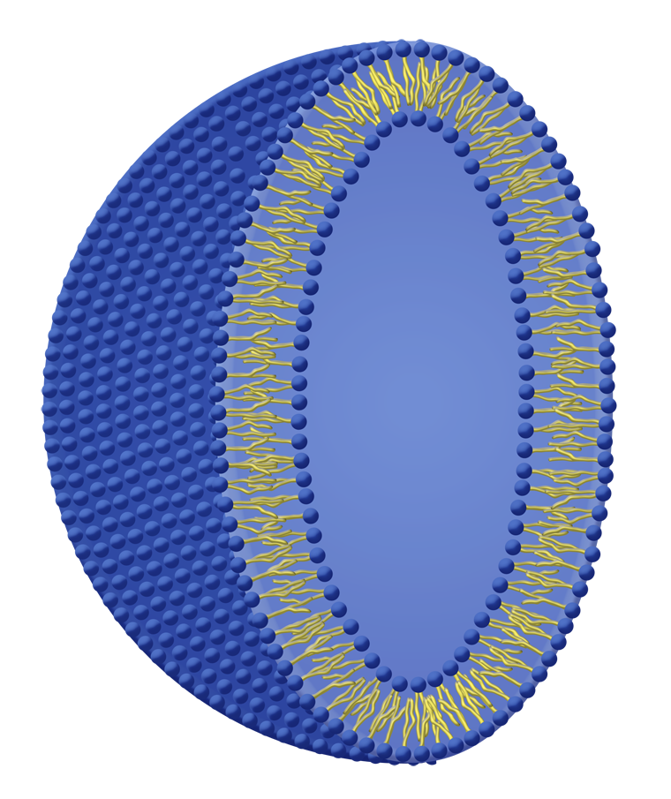(a)

|  |
| --- |
| Figure: (a) Schematic drawings and images should be of sufficient resolution for reproduction.  (b) Graph symbols and legends should be clearly readable in a reduced format. |

References [1] should be cited in square brackets [2] and listed at the end of the abstract [3,4].

[1] References should at least give the first author, the *journal in italic*, **volume** (bold), page number and (year).

[2] If space is available, all authors may be listed, otherwise first three authors followed by *et al.,*.

[3] P. Debye, H.R. Anderson and H. Brumberger, *J. Appl. Phys.* **28**, 679 (1957).